What Does the ICT Industry Want from Work-Integrated Learning?

Summary of Survey Responses

# Data Collection

The survey was distributed by e-mail to past participants in COMP 3018 Professional Experience, members of Launch Pad, and through personal networks such as LinkedIn. In total, 43 responses were received by 15 April 2024. Responses that had not answered at least four questions are eliminated from the analysis, as Questions 1-3 refer only to demographic data without any reference to work-integrated learning. This left 23 responses for analysis.

## Limitations

Since many respondents were recruited by prior participation in COMP 3018 or other engagement with academic institutions, responses may be biased towards organisations already disposed to participate in work-integrated learning programmes.

Most (but not all) respondents are likely to be based in the Sydney region. Responses may not be representative of organisations in non-metropolitan regions or organisations based outside Australia.

# Findings

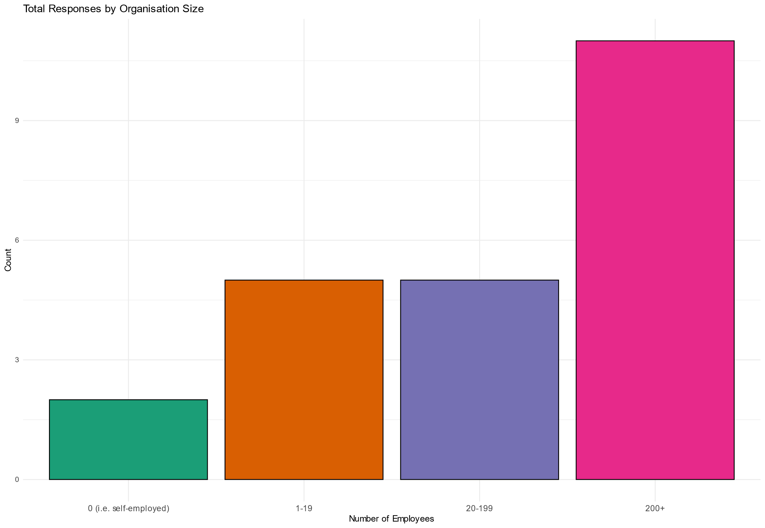

Figure 1: Number of responses by size of organisation

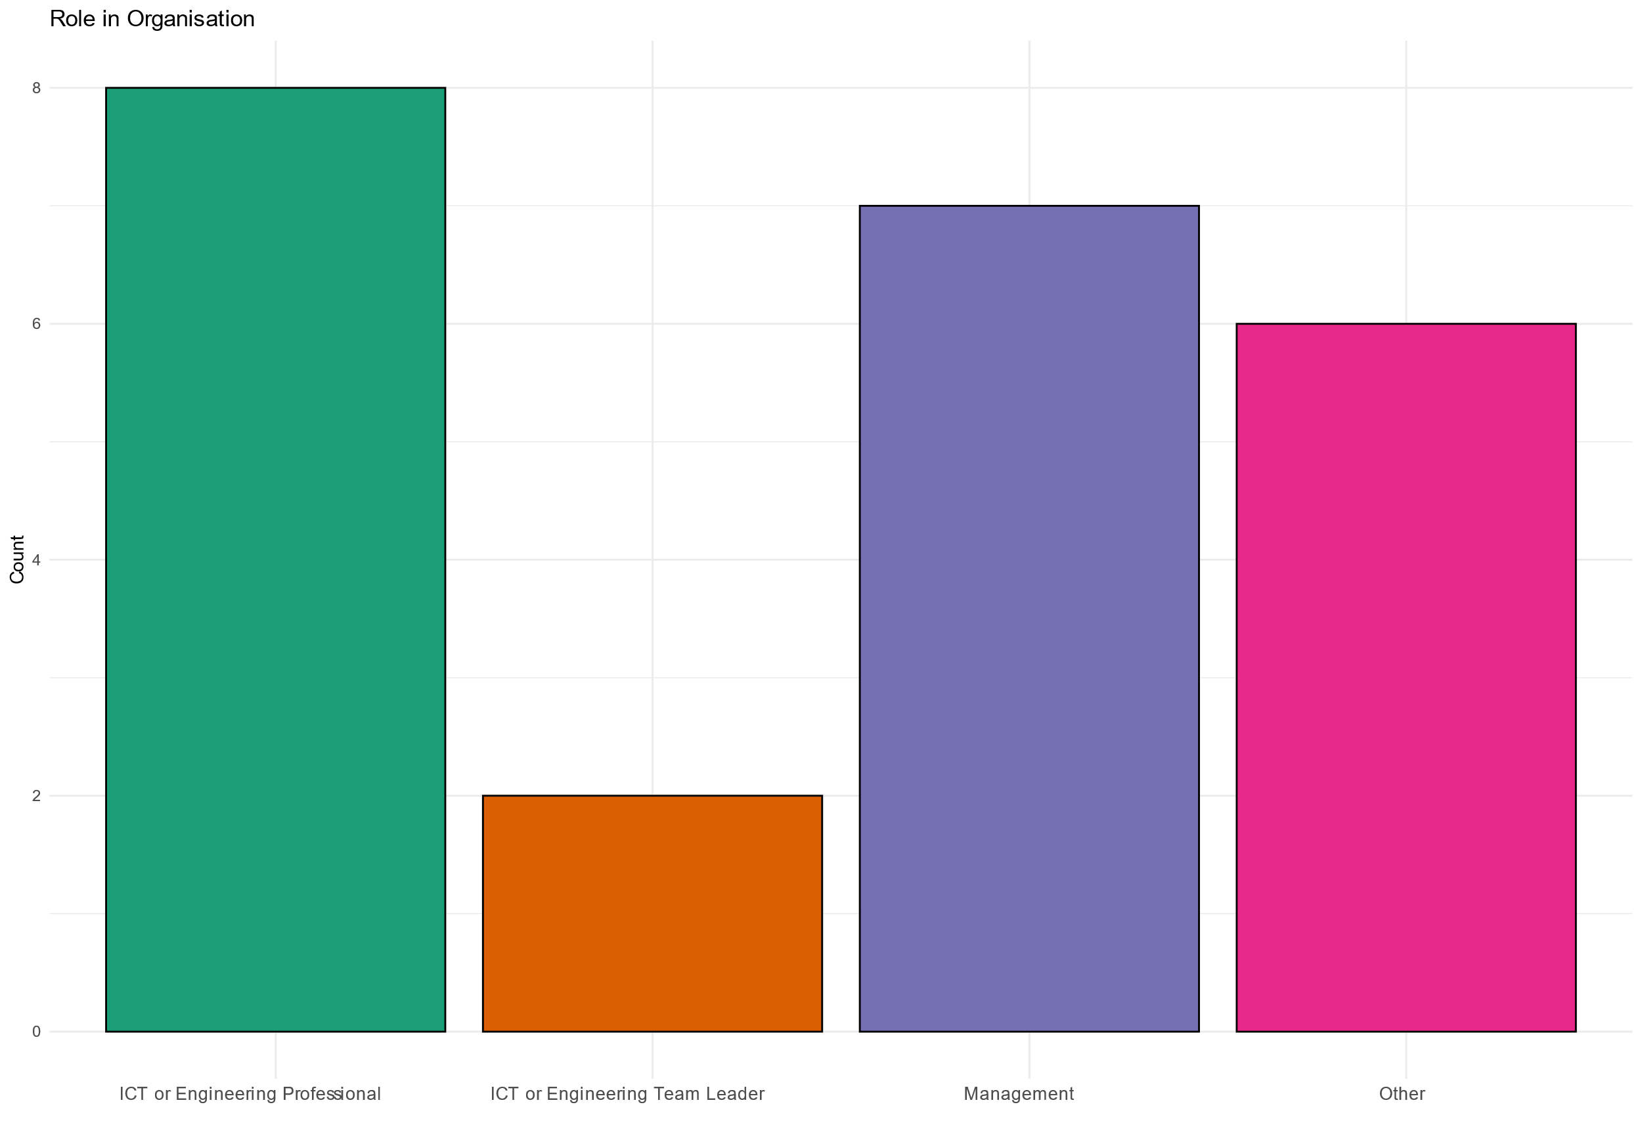

Figure 2: Number of responses by role in organisation.

Figures 1, 2 and 3 show the number of responses by organisational role, organisation size and industry sector, respectively. Around half of the respondents are ICT or engineering professionals (including team leaders), a quarter are managers, and the remainder are from other professions. Almost half of the respondents work in large organisations (those with more than 200 employees), with the rest evenly divided between small and medium-sized organisations.

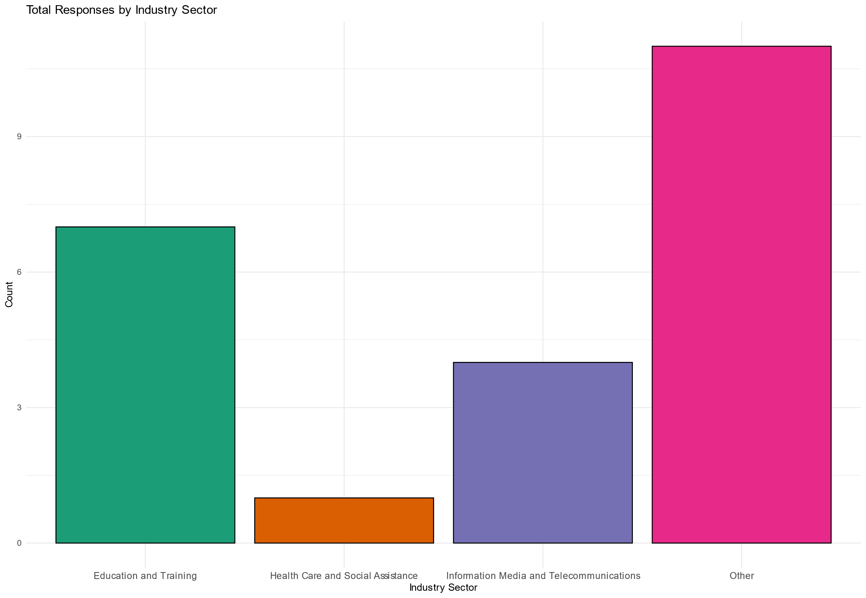

Figure 3: Number of responses by industry sector.

Surprisingly few respondents work in the Information, Media and Telecommunications industry. Some ICT workers may have chosen the sector for which their organisation develops software rather than “IMT” (for example, an organisation that produces software for cars may consider itself part of the “transport” industry). Many respondents work in educational institutions—possibly in departments of Western Sydney University that have provided student projects in the past—but half work in sectors not identified in the survey.

## Q4: Forms of WIL

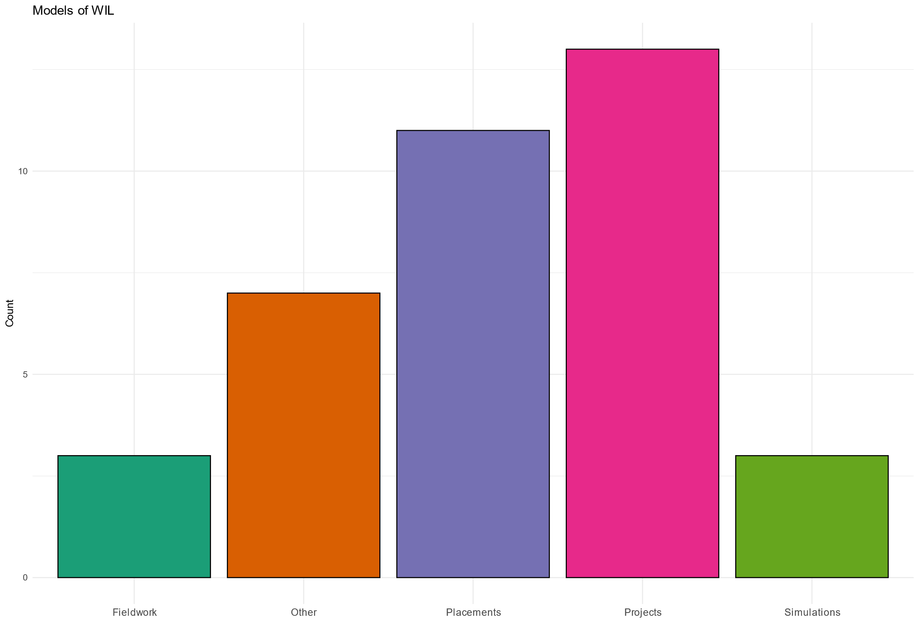

Figure 4: Forms of WIL (used or expected).

Figure 4 shows that placements and projects are the most common form of work-integrated learning used or expected by respondents. No significant differences were observed between organisation sizes, organisational roles, or industry sector.

Projects (such as COMP 3018) are widely used in computing courses and many computing firms offer internships. A surprising number of respondents selected the “other” category, which was intended to capture forms of WIL not categorised by the NPILF guidance document, but may conceivably represent respondents misunderstanding the “project” and “placement” terminology used in the survey.

Note: Figure 4 differs slightly from the corresponding graphs in Vishwa’s report because her report includes only responses that answered *more than* four questions, whereas the figure here shows responses that answered *at least* four questions.

## Q5: Resources committed to WIL

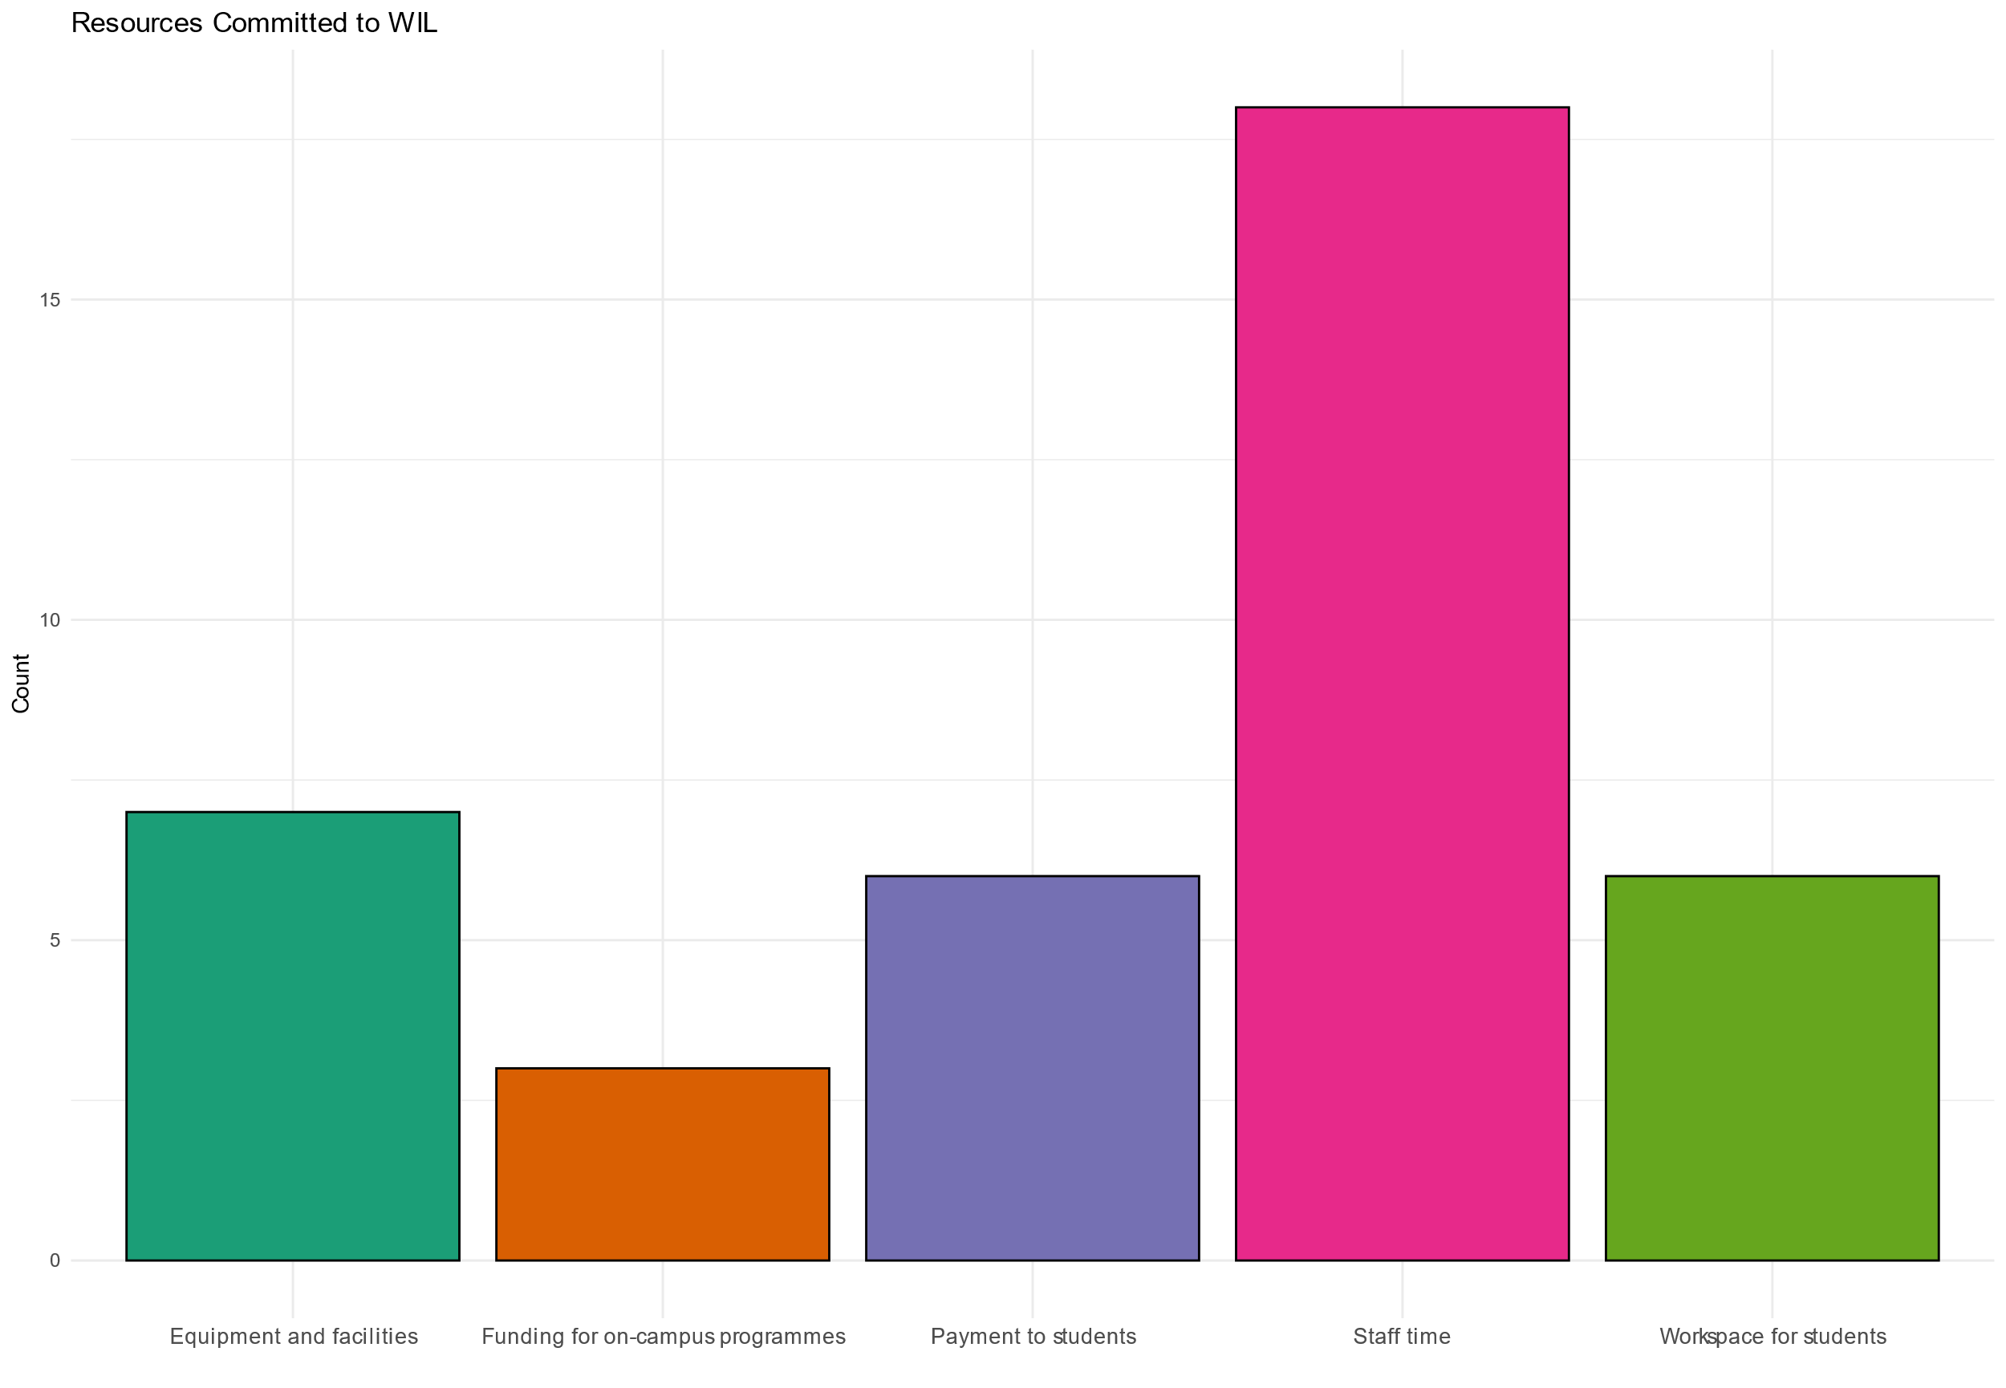

Figure 5: Resources committed to WIL (in past or future).

Staff time is by far the most common resource that respondents are willing to commit, but some are also willing to offer facilities, workspaces, and payment (presumably for hiring interns). Respondents showed little interest in on-campus programmes, though this could be because such programmes don't exist to our knowledge.

No significant differences were observed between organisation sizes, organisational roles, or industry sector.

## Q6: Reasons for participating in WIL

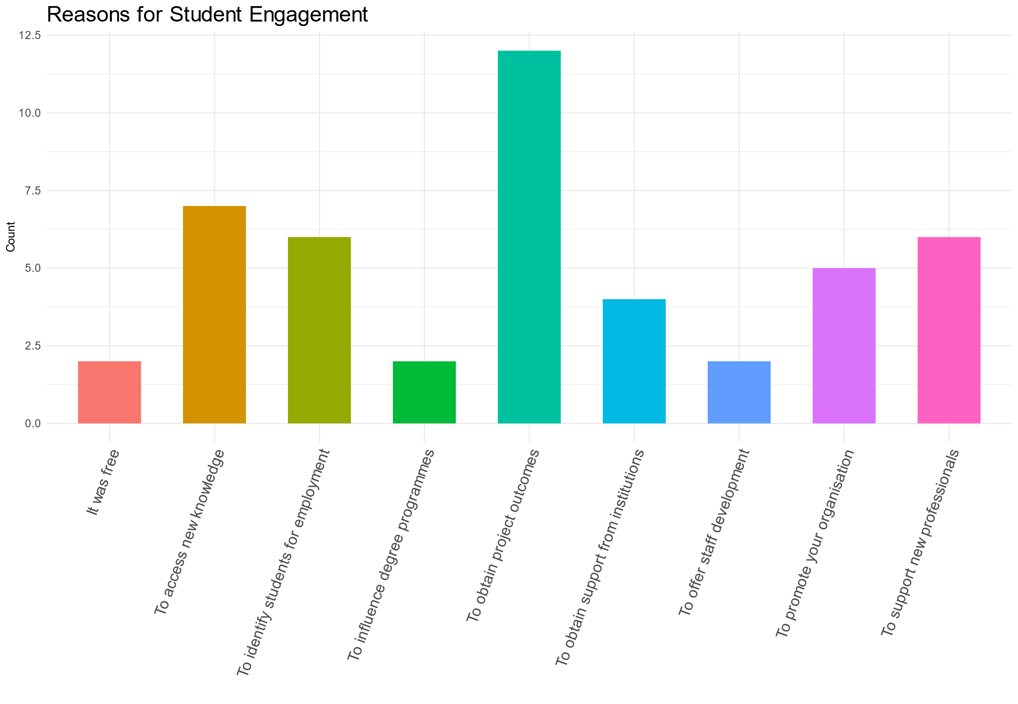

Figure 6: Reasons for engaging in WIL.

Figure 6 shows that obtaining project outcomes is the most common reason to engage in WIL, with other common reasons being identifying students for employment, supporting new professionals, promoting the organisation, and obtaining new knowledge.

No significant differences were observed between organisation sizes, organisational roles, or industry sector.

## Q7: Barriers to engagement in WIL

The largest barrier to WIL by a small margin is lack of projects suitable for students; the other responses are evenly distributed across the options given. It is surprising that several respondents said they weren't aware of WIL, given that the survey was distributed to organisations who’d been involved in COMP 3018, but these responses may represent respondents contacted through other networks or respondents not understanding the term “work-integrated learning”.

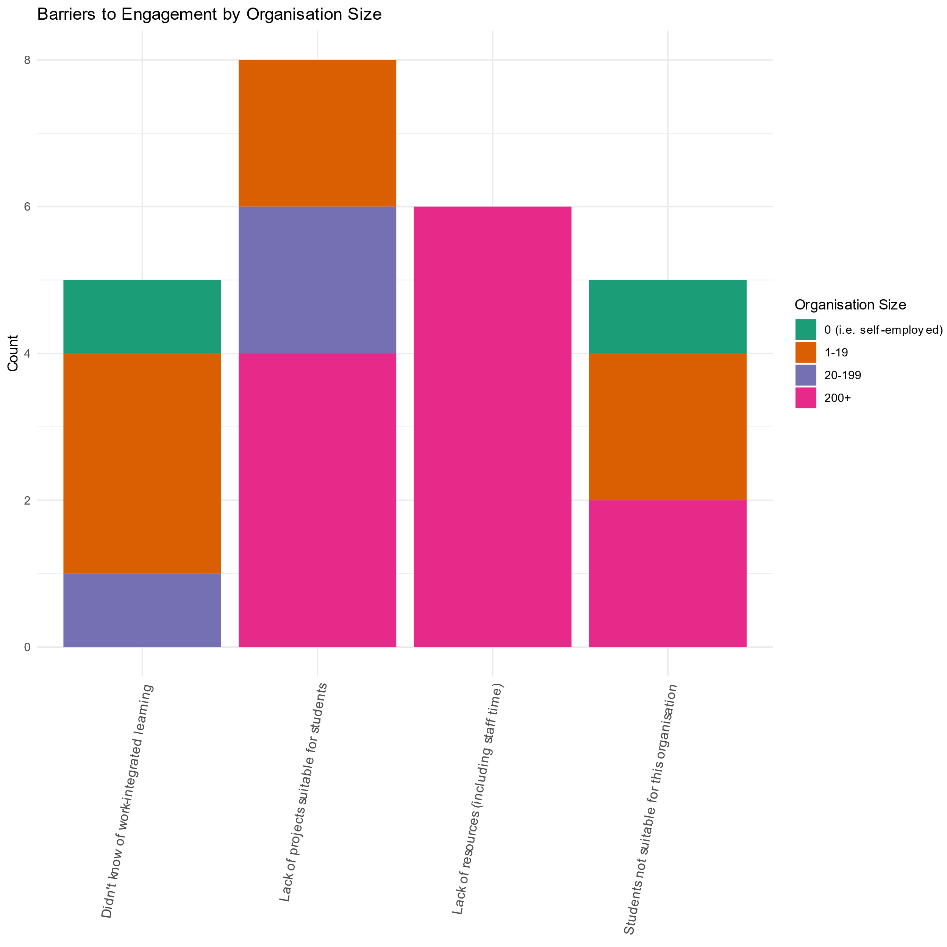

Figure 8: Barriers to engaging in WIL by size of organisation.

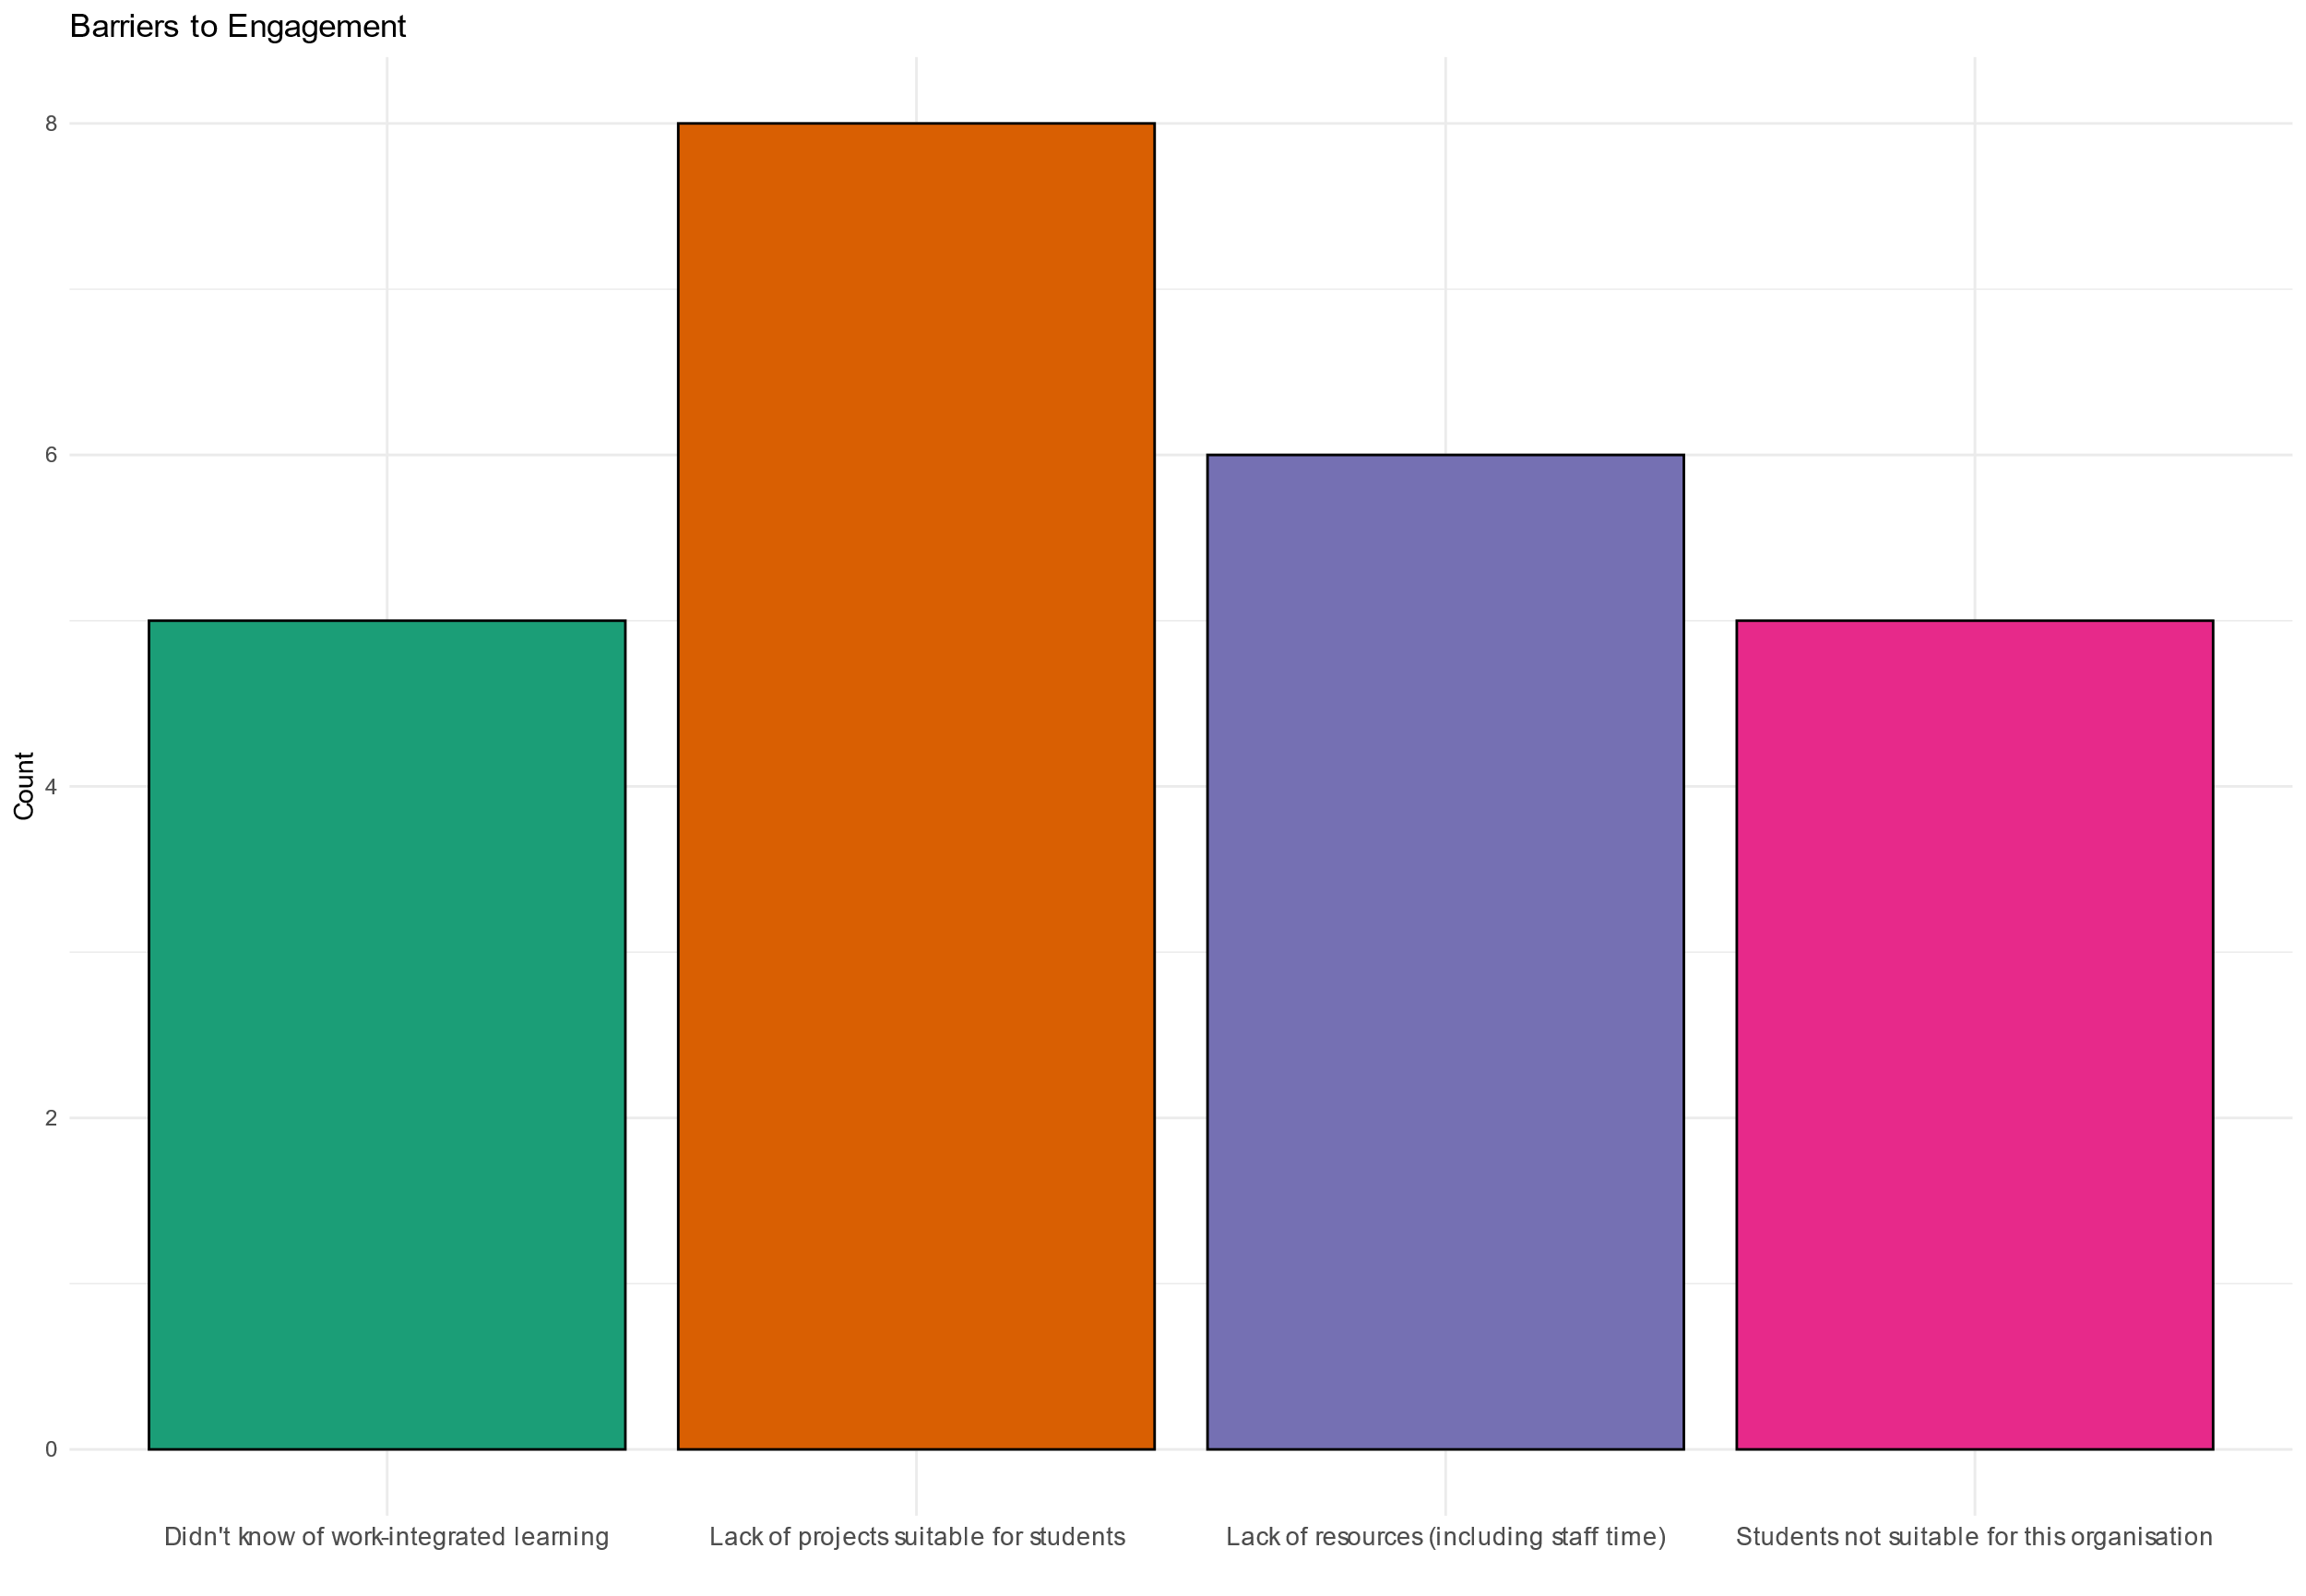

Figure 9: Barriers to engaging in WIL.

One curious result is that only respondents from large organisations chose “lack of resources” as a barrier. From the personal experience of the research team [Anupama], this may be because large organisations have more complex procedures for approving funding, which respondents perceive as being unable to obtain resources.

Also from personal experience of the research term [Nicholas], lack of projects suitable for students is also a barrier for co-ordinators of subjects that don’t currently contain work-integrated learning. In a review of work-integrated learning within SCDMS carried out in 2019, some subject co-ordinators doubted that first- and second-year students had the ability work on “real-world” problems, and others feared that real-world problems could not be fit into the university semester.

## Q8: Terms of engagement

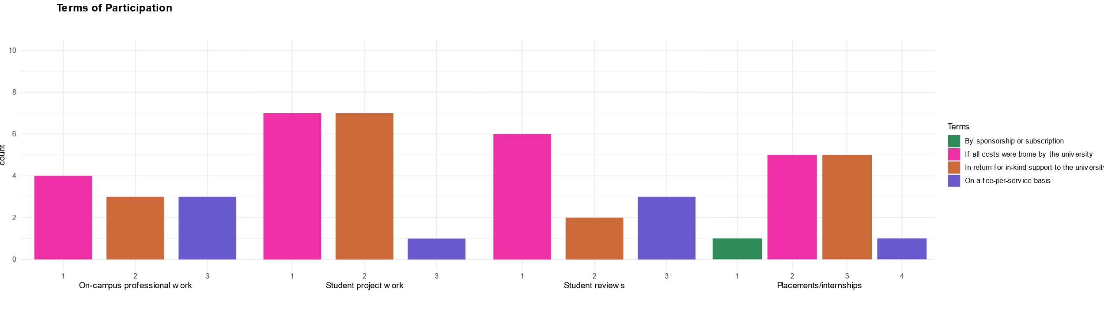Unsurprisingly, respondents found WIL activities in which all costs are borne by the university most appealing. However, there also exists some interest in exchanging in-kind support to the university.

Figure 10: Preferred terms of engagement.

## Q9: Fields of expertise

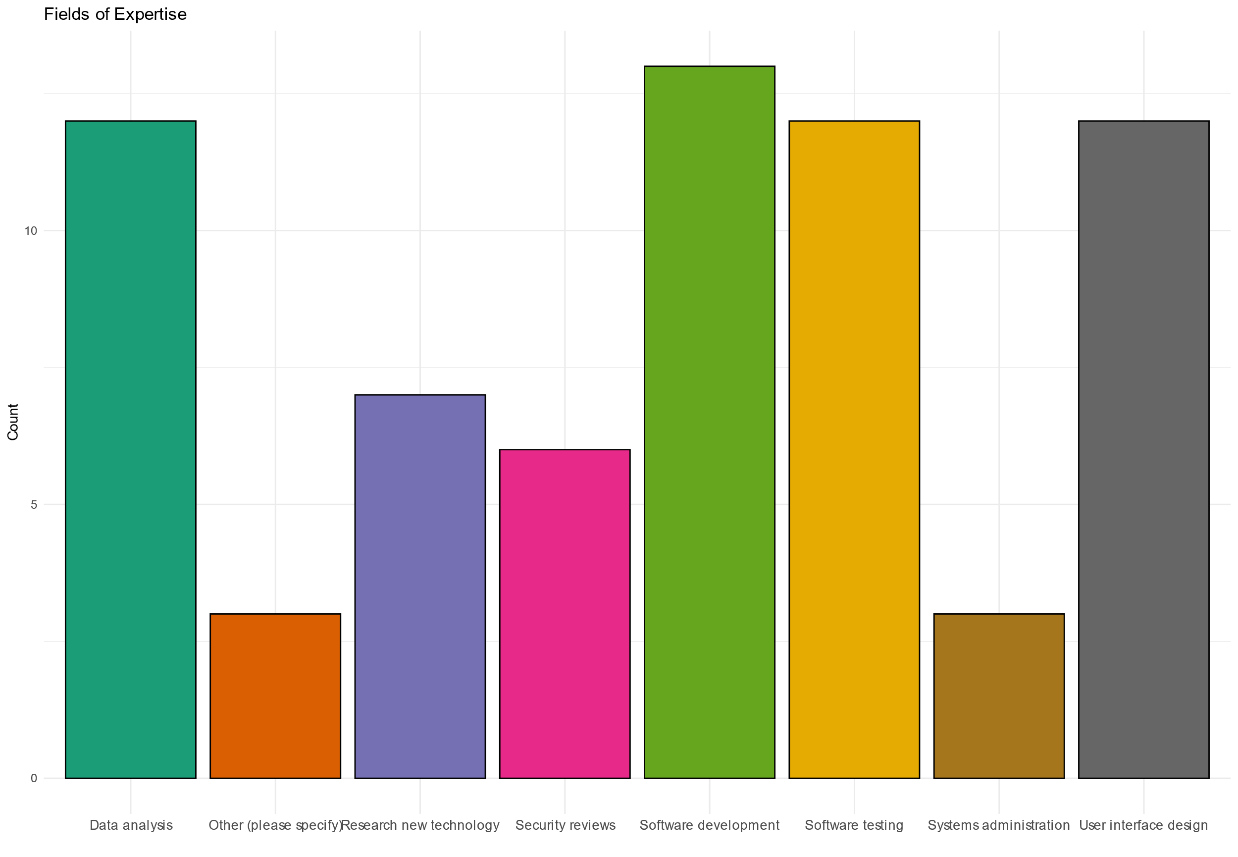

Figure 11: Desired fields of expertise for engagement in WIL.

Figure 11 shows that software development, software testing, user interface design and data analysis are the fields of expertise most desired by respondents, though all of the options given received at least a few responses. No significant differences were observed between organisation sizes, organisational roles, or industry sector.

The fields chosen may reflect the make-up of our respondents, who are connected to COMP 3018 (a software development project) or computer science academics. Organisations working in cyber security, for example, might be more likely to choose security reviews.

## Q10: Additional comments

Only three respondents left free-text comments. One of these was a comment “project experience is well run” and another was additional explanation of the background of the respondent. The remaining comment, from a respondent at a large education institution who selected “other” for the organisational role question, wrote:

Having students working on projects has been rewarding. They often have great ideas and are fantastic at taking the time and effort to listen to what is needed and to work with you to get what you want. It is a win-win situation with their enthusiasm and commitment reaping the rewards in what is achieved. In addition, it is great to have some input into what is happening with the students and to help to make them more competitive when they complete their course with some industry experience.

# Future Work

In view of the low number of responses, no strong conclusions can be drawn from the data, but some common responses suggest lines of thinking that might be followed up in future research.

## The number of respondents working in the ICT industry

Does the relatively small number of respondents working in the Information, Media and Telecommunications industry indicate that the ICT industry is not strongly engaged with work-integrated learning, or that Western Sydney does not have a strong ICT sector, or something else?

## Reasons for participating in work-integrated learning

Obtaining project outcomes is a very common reason for organisations to participate in work-integrated learning, but is probably not what educators would say is the most important outcome. Should access to new knowledge, identifying students for employment, and other popular responses be given greater prominence in promoting WIL programmes? On the other hand, would organisations be more inclined to participate in WIL programmes if the university could promise stronger project outcomes (for example, by providing students with more support)?

## Making projects suitable for students

Might educators assist in identifying projects where organisations perceive a lack of projects suitable for students?

## Engaging large organisations

If the conjecture about members of large organisations finding it difficult to obtain resources is correct, does engaging with such partners require scaffolding with memoranda of understanding, long-term partnerships, or other support?

## Other forms of work-integrated learning

Finally, what are the “other” forms of work-integrated learning identified in Question 4?

# Acknowledgements

The research team would like to acknowledge the assistance of Vishwa Raval, who contributed to the construction of graphs and analysis of data as part of the Summer Research Scholarship Scheme 2023-24.